Activity 2C Report (TEAM-1)

Table of Contents

Table of Figures 3

Table of Tables 4

ACTIVITY 1: SYSTEM/ SOFTWARE DEVELOPMENT 4

**INTRODUCTION** 4

**MY PRODUCT: “Scientific Calculator ”** 6

**REQUIREMENTS** 7

Research………………………………………………………………………………………………………………………………………………….

Ageing

Costing

Pros and Cons

WWWWH…………………………………………………………………………………………………………………………………………….

High level Requirements……………………………………………………………………………………………………………………………

Low level Requirements………………………………………………………………………………………………………………………….

**SWOT ANALYSIS**  7

**DESIGN** 8

High Level Design 8

Low Level Design

**TEST PLANS** 13

Low Level Test Plan……………………………………………………………………………………………………………………

High Level Test Plan…………………………………………………………………………………………………………………

## Table of Tables

Table 1 AGING 6

Table 2 GRADING COST 6

Table 3 REQUIREMENTS 8

Table 4 HIGH LEVEL TEST PLAN 15

Table 5 LOW LEVEL TEST PLAN 16

Table 6 USER STORIES 17

Table 7 AGING 19

Table 8 GRADING COST 19

Table 9 REQUIREMENTS 21

Table 10 USER STORIES 27

**SCIENTIFIC CALCULATOR**

**INTRODUCTION**

A Calculator is an electronic [hardware](https://www.computerhope.com/jargon/h/hardware.htm) [device](https://www.computerhope.com/jargon/d/device.htm) or [software](https://www.computerhope.com/jargon/s/software.htm) capable of performing mathematical calculations, such as addition, multiplication, subtraction, or division. The Casio Computer Company developed the first electronic calculator in 1957. Since then, calculators have come in many sizes, and are also built into most operating systems on computers, smartphones, and tablets.

**REQUIREMENTS**

1. **Research**
2. **Ageing**

|  |  |  |  |
| --- | --- | --- | --- |
| 1960s | 1980s | 2000 | Present |
| Calculators with small keyboards having paper tapes for output display. | Calculator with 12-digit display in red LED and with integrated circuits. | Introduction of graphing calculators, affordable, dual powered with liquid display. | Advanced calculators which can handle higher level math which is ideal for everything from economics to computer science. |

1. **Cost**

|  |  |  |  |
| --- | --- | --- | --- |
| 1960s | 1980s | 2000 | Present |
| 360$-400$ | 700$-800$ | 20$-30$ | 10$-12$ |

1. **Pros and Cons**
2. Pros

* More operations possible.
* Efficient
* User friendly

1. Cons

* High cost
* Need to have some knowledge for operating calculators.

1. **WWWWH**
2. what is Calculator?

* A Calculator is a simple electronic hardware device or a software capable of performing the simple calculations such as addition,multiplications,subtraction,division,finding square roots,percentages and conversions etc.
* In 1957,the Casio computer company developed the first electronic calculator.
* A simple numeric keypad is present to enter the numbers into the calculator.
* Calculators can also built into most operating systems on computers,smart phones and also tablets.

1. Where we use Scientific Calculator?

* Examination halls
* Colleges
* Computers
* Labs

1. When we use calculators?

Calculators are useful during examinations for getting complex calculations in very less time. For finding trigonometric values, hyperbolic functions, inverses. While calculating bills in malls and restaurants, these calculators are very useful. Engineering students will use this type of calculator to do complex operations on power values, exponentials etc.

1. Why we use calculators?

* Complex calculations are very tough to calculate in less time.So this scientific calculator is useful for all operations.
* To get the results very accurately.
* To save our valuable time.
* Saves human power.

1. How to make the Scientific calculator?

Input will be given by the user from the keyboard and the result will be displayed to the screen i,e output will be on the screen.

* Write the code for all the requirements.
* Use one programming language for coding the required functions.
* Use ‘C’ programming language for the purpose of coding to make this scientific calculators.
* Use github and visual studio for making and building file for required specifications.
* Use electronic hardware to embedded code into the processor.
* Check correctly of all functionalities.

1. **HIGH LEVEL REQUIREMENTS**

|  |  |
| --- | --- |
| REQ_ID | DESCRIPTION |
| RH_01 | Must perform all the basic arithmetic operations such as addition, subtraction, multiplication and division along with the other operations such as trigonometry ,factorial, logarithmic functions, exponentials,simple interest, power of a number, average, conversions of numbers |
| RH_02 | In any situation, the calculator must produce a correct result defined by the well-known arithmetic rules. |
| RH_03 | user to resolve the erroneous If the calculations are impossible the calculator must display information helping the situation |

1. **LOW LEVEL REQUIREMENTS**

|  |  |
| --- | --- |
| REQ ID | DESCRIPTION |
| RL_01 | If the user enters a negative number as input for factorial calculation, the calculator displays a custom error message**.** |
| RL_02 | If the user enters a zero as input for denominator in division calculation, the calculator displays a custom error message |
| RL_03 | User should enter the input either in degree form or radians form |
| RL_04 | If the user enters a higher number as input in Conversion calculation, the calculator displays only 8 bits |
| RL_05 | If the user enters a improper input in exponential, it displays an error message if the output is infinity |
| RL_06 | If the user enters a negative number as input for base in logarithmic functions, the calculator displays a custom error message |
| RL_07 | User should enter the input time in years and rate in percentage in Simple interest |
| RL_08 | User should enter base and power correctly |
| RL_09 | User should enter all the numbers correctly and number of items that should be Average |

**SWOT ANALYSIS**

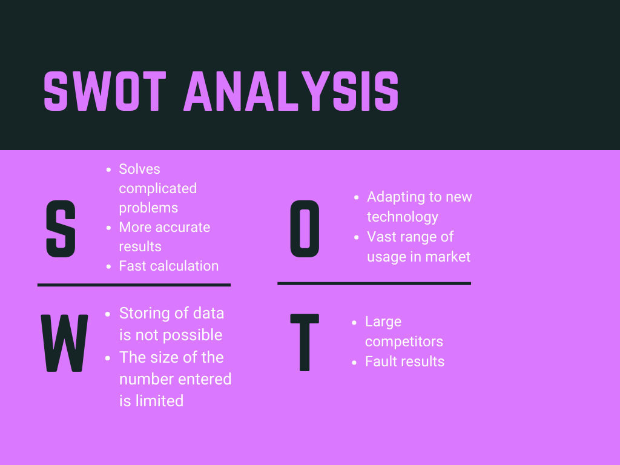

**DESIGN**

1. **HIGH LEVEL DESIGN** 
   1. **STRUCTURAL DIAGRAM**

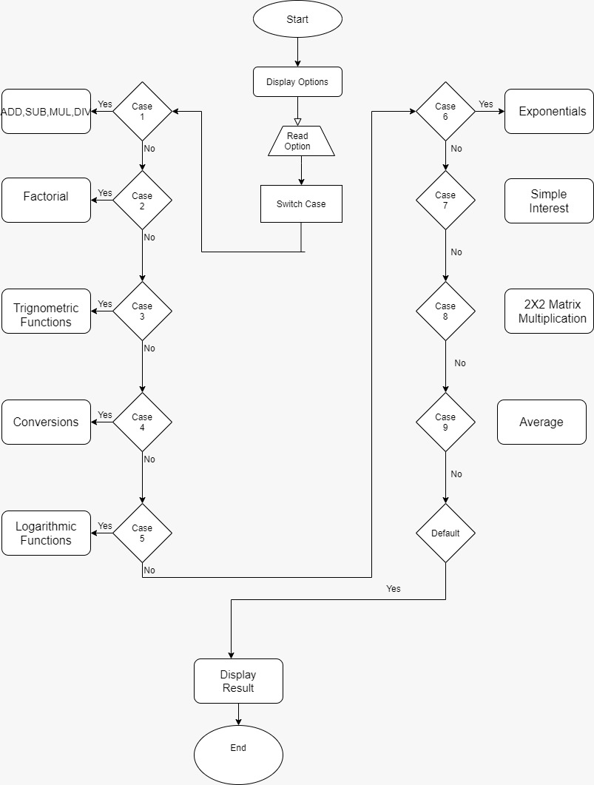

* 1. **BEHAVIORAL DIAGRAM**

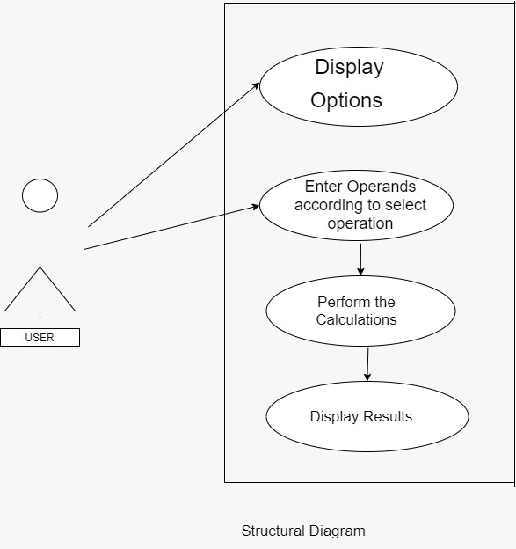

1. **LOW LEVEL DESIGN**
   1. **SIMPLE OPERATOR STRUCTURAL DIAGRAM**

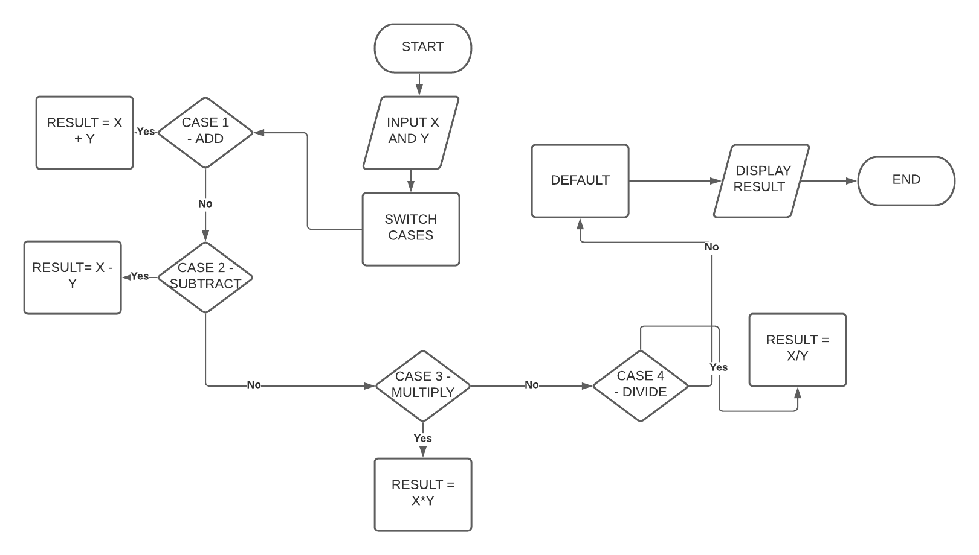

* 1. **SIMPLE OPERATOR BEHAVIOURAL DIAGRAM**

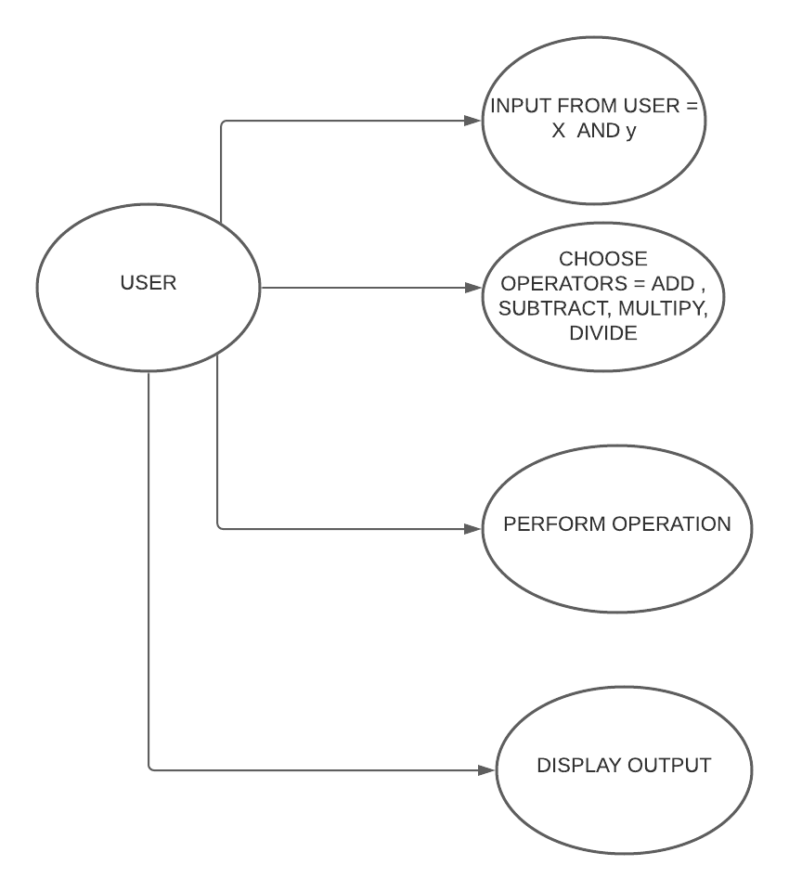

* 1. **LOGARITHMIC BEHAVIOURAL DIAGRAM**

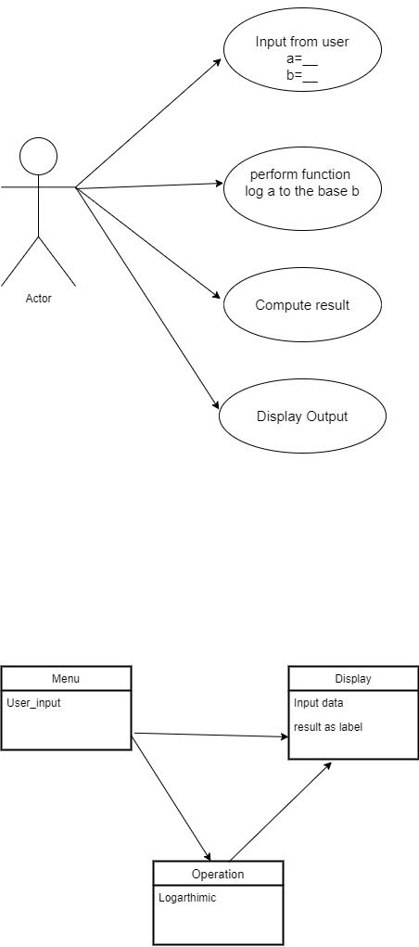

* 1. **LOGARITHMIC STRUCTURAL DIAGRAM**

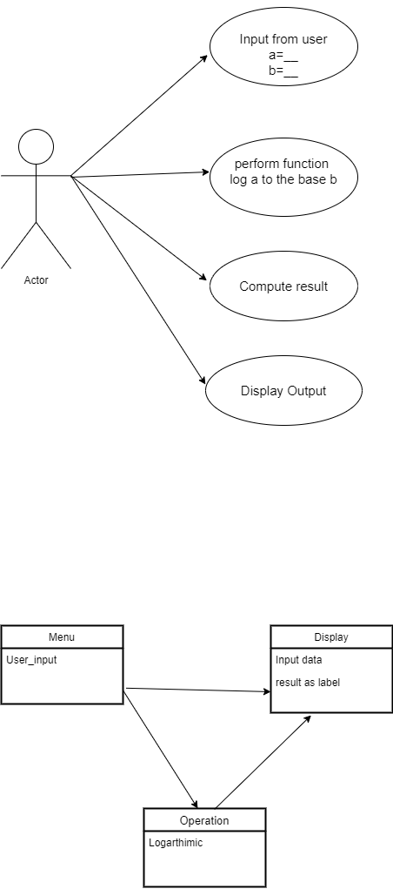

* 1. **TRIGNOMETRY BEHAVIOURAL DIAGRAM**

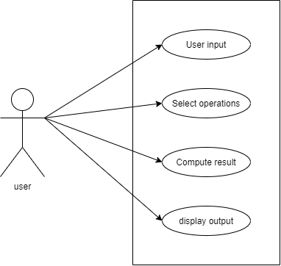

* 1. **TRIGNOMETRY STRUCTURAL DIAGRAM**

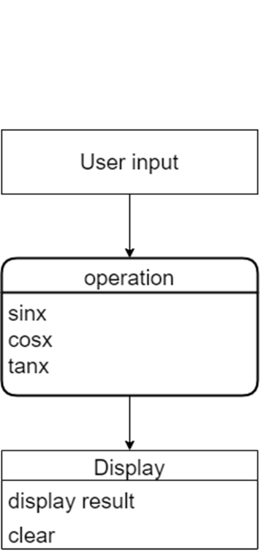

* 1. **POWER BEHAVIOURAL DIAGRAM**

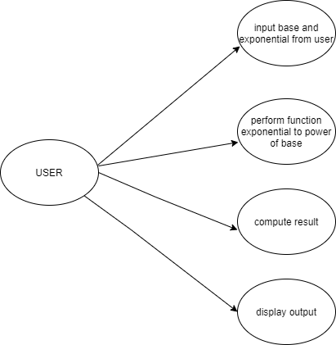

* 1. **POWER STRUCTURAL DIAGRAM**

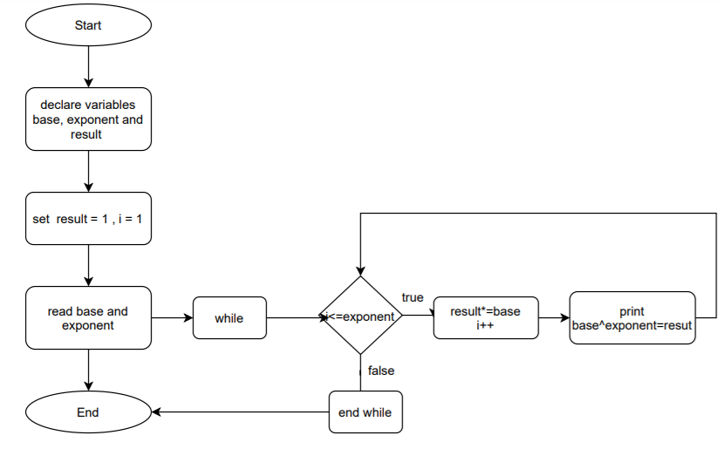

* 1. **EXPONENTIAL BEHAVIOURAL DIAGRAM**

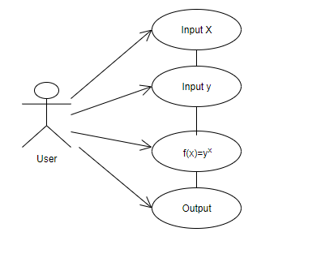

* 1. **EXPONENTIAL STRUCTURAL DIAGRAM**

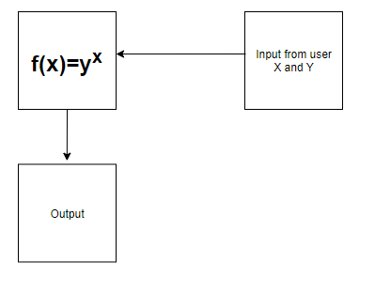

* 1. **SIMPLE INTEREST BEHAVIOURAL DIAGRAM**

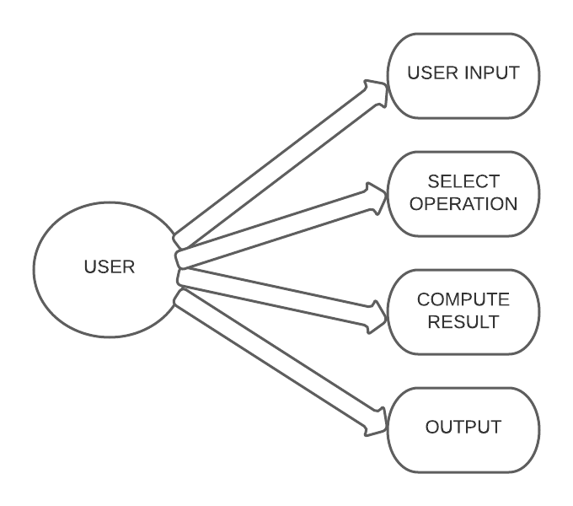

* 1. **SIMPLE INTEREST STRUCTURAL DIAGRAM**

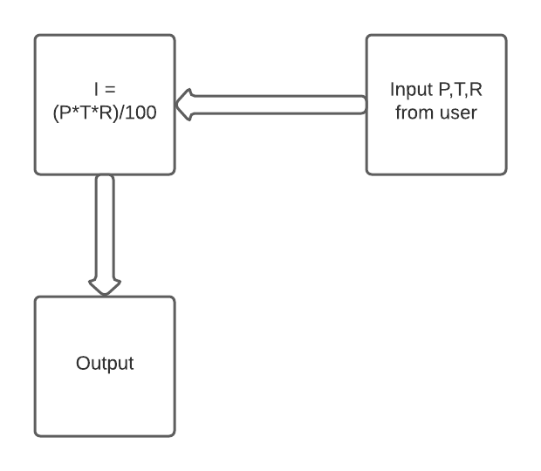

* 1. **CONVERSIONS BEHAVIOURAL DIAGRAM**

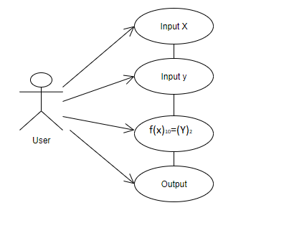

* 1. **CONVERSIONS STRUCTURAL DIAGRAM**

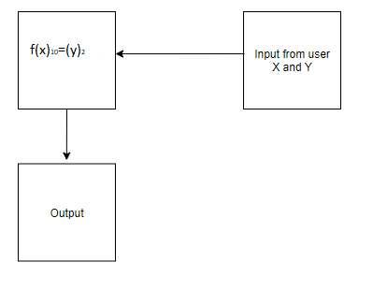

* 1. **AVERAGE OPERATION BEHAVIOURAL DIAGRAM**

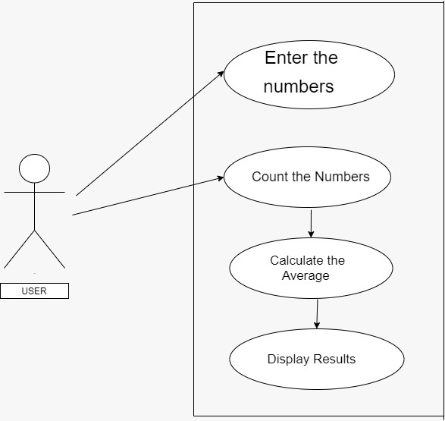

* 1. **AVERAGE OPERATIONS STRUCTURAL DIAGRAMS**

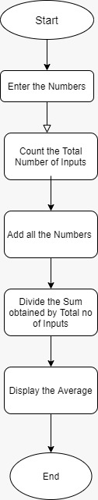

* 1. **FACTORIAL STRUCTURAL DIAGRAM**

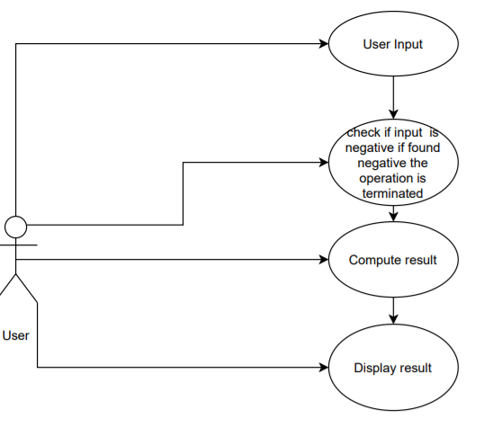

* 1. **FACTORIAL BEHAVIOURAL DIAGRAM**

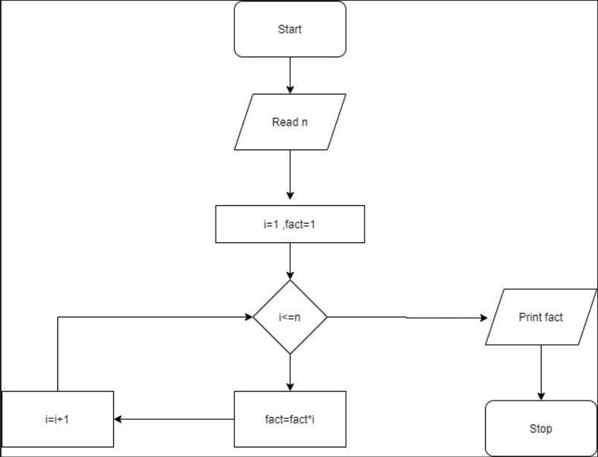

**TEST PLAN**

1. **HIGH LEVEL TEST PLAN**

|  |  |
| --- | --- |
| TEST ID | **DESCRIPTION** |
| HL_01 | Include buttons with number 0-9 and all the function buttons |
| HL_02 | It should have ON, OFF, Storage unit |

1. **LOW LEVEL TEST PLAN**

|  |  |  |  |  |
| --- | --- | --- | --- | --- |
| **TEST ID** | **DESCRIPTION** | **INPUT** | **ACTUAL OUTPUT** | **EXPECTED OUTPUT** |
| TL_01 | Addition of two numbers | A=2,B=5 | C=7 |  |
| TL_02 | Subtraction of two numbers | A=5,B=2 | C=3 |  |
| TL_03 | Multiplication  of two numbers | A=5,B=2 | C=10 |  |
| TL_04 | Division of two numbers | A=4,B=2 | C=2 |  |
| TL_05 | Factorial of two numbers | A=3 | C=6 |  |
| TL_06 | Trignometric  (Tan x) | X=45 | C=1 |  |
| TL_07 | Conversion  (dec to bin) | A=2 | C=0010 |  |
| TL_08 | Exponentials | X=1 | C=2.71 |  |
| TL_09 | Simple interest | P=1000  T=2  R=10% | C=200 |  |
| TL_10 | Power | A=2,B=1 | C=2 |  |
| TL_11 | Average | A=2,B=6 | C=4 |  |